**Automatic Toll Collection using RF**

Toll collection in highways and private roads is carried on by governments and some private companies. This field has a lot of problems faced by travelers and also a lot of time and money is wasted. Travelers have to wait in long queues and there are also cases where toll collecting employees been harassed or even killed. There are also a lot of charges on the people collecting tolls that they are rude and even there are irregularities in collecting tolls. Looking at a broader level, there is huge loss of fuel being wasted every year waiting at toll which gives rise to global warming.

All this can be avoided if we use automatic toll collection using RF.

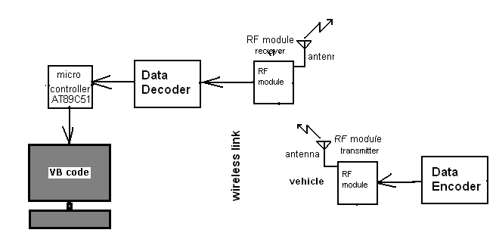

Block Diagram

The figure above shows the block diagram automatic toll collection using RF. There are two parts in the diagram. The right hand side of the diagram is vehicle that consists of RF Transmitter that will transmit its identity whenever it will pass through this toll collection centre and the left hand side is the toll collection center that consists of RF Receiver and interface to PC. The RF Rx at toll collection centre will receive the data from vehicle & deduct the amount of toll as per the tariff. One of the pre-requisites for this project will be that PC should consist of databases of all the vehicles (Vehicle number, account status, etc.) that can be taken from RTO’s in a central database. The database will be designed with VB. The microprocessor will be used along with RF receiver and it has to be coded using C programming language. Kiel is the software that can be used for programming the microcontroller. Here, the decoder and encoder will play a very important role where it will be used for encoding the vehicle number in RF transmitter and vice versa in receiver side. The antenna will be used for wireless communication between both sides.

The main advantage of this kind of system would be reduction of time to collect toll taxes and also it will help in automating the toll process that will help in analysis of the data i.e. the total number of vehicles in month, year, etc. and all the illegal vehicles or lost vehicles can also be tracked.